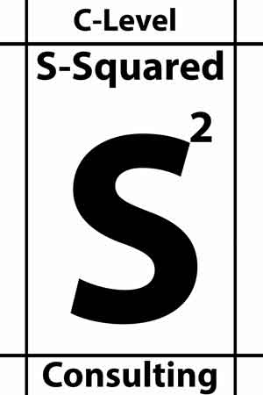 |  | Cost optimization
- Telco/Network Contract Review & Optimization
- Network Architecture for Best Service
- Resolving Technical Debt
- Budgeting Best Practice
- Improving the IT Operating Model
- IT Service Portfolio & Catalog
- Cost Optimization as a discipline across the business
About  S-Squared is an IT network and infrastructure consulting firm. Our main focus is to determine if your network and infrastructure are the right size for your business. S-Squared can assist with contracts, contract negotiations and full infrastructure architecture.  CONTACT  Scott Sampson  PHONE:  (602) 549-8945  EMAIL:  Scott.Sampson@s-squaredllc.com  www.s-squaredllc.com |  | Additional Services
Strategic Planning
- Organizational Design Optimization
- Strategic Road mapping
- Business Capabilities Modeling
- Innovation & Product Maturity

Digital Transformation & Acceleration
- Cloud Strategy & Migration
- COE Creation, Governance and Value Creation
- AI/ML/VR/AR Tends, Opportunities & Road mapping
- IT/OT Alignment, Integration, Culture, Value Enhancement
- Complex Initiative Guidance/Oversight

Mergers & Acquisitions
- Technical Deal Assessment
- Due Diligence Best Practice
- Integration planning
- Synergy Assessment and Attainment
- Playbook Creation & Best Practice

 |  | Impactful Delivery
- Regular Consultations
- Customized Onsite Presentations
- Customized Onsite Workshops
- Frameworks/Roadmaps
- Client Content Review and Commentary
- Third Party Content Review and Commentary
- Leadership Team Group Engagement
- Product Assesment
- Customized M&A Activity Playbooks
- Individual & Team Assessments

